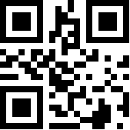**C2Ag4yy (this is the code stored in the QR Image, which should be written below the QR code)**